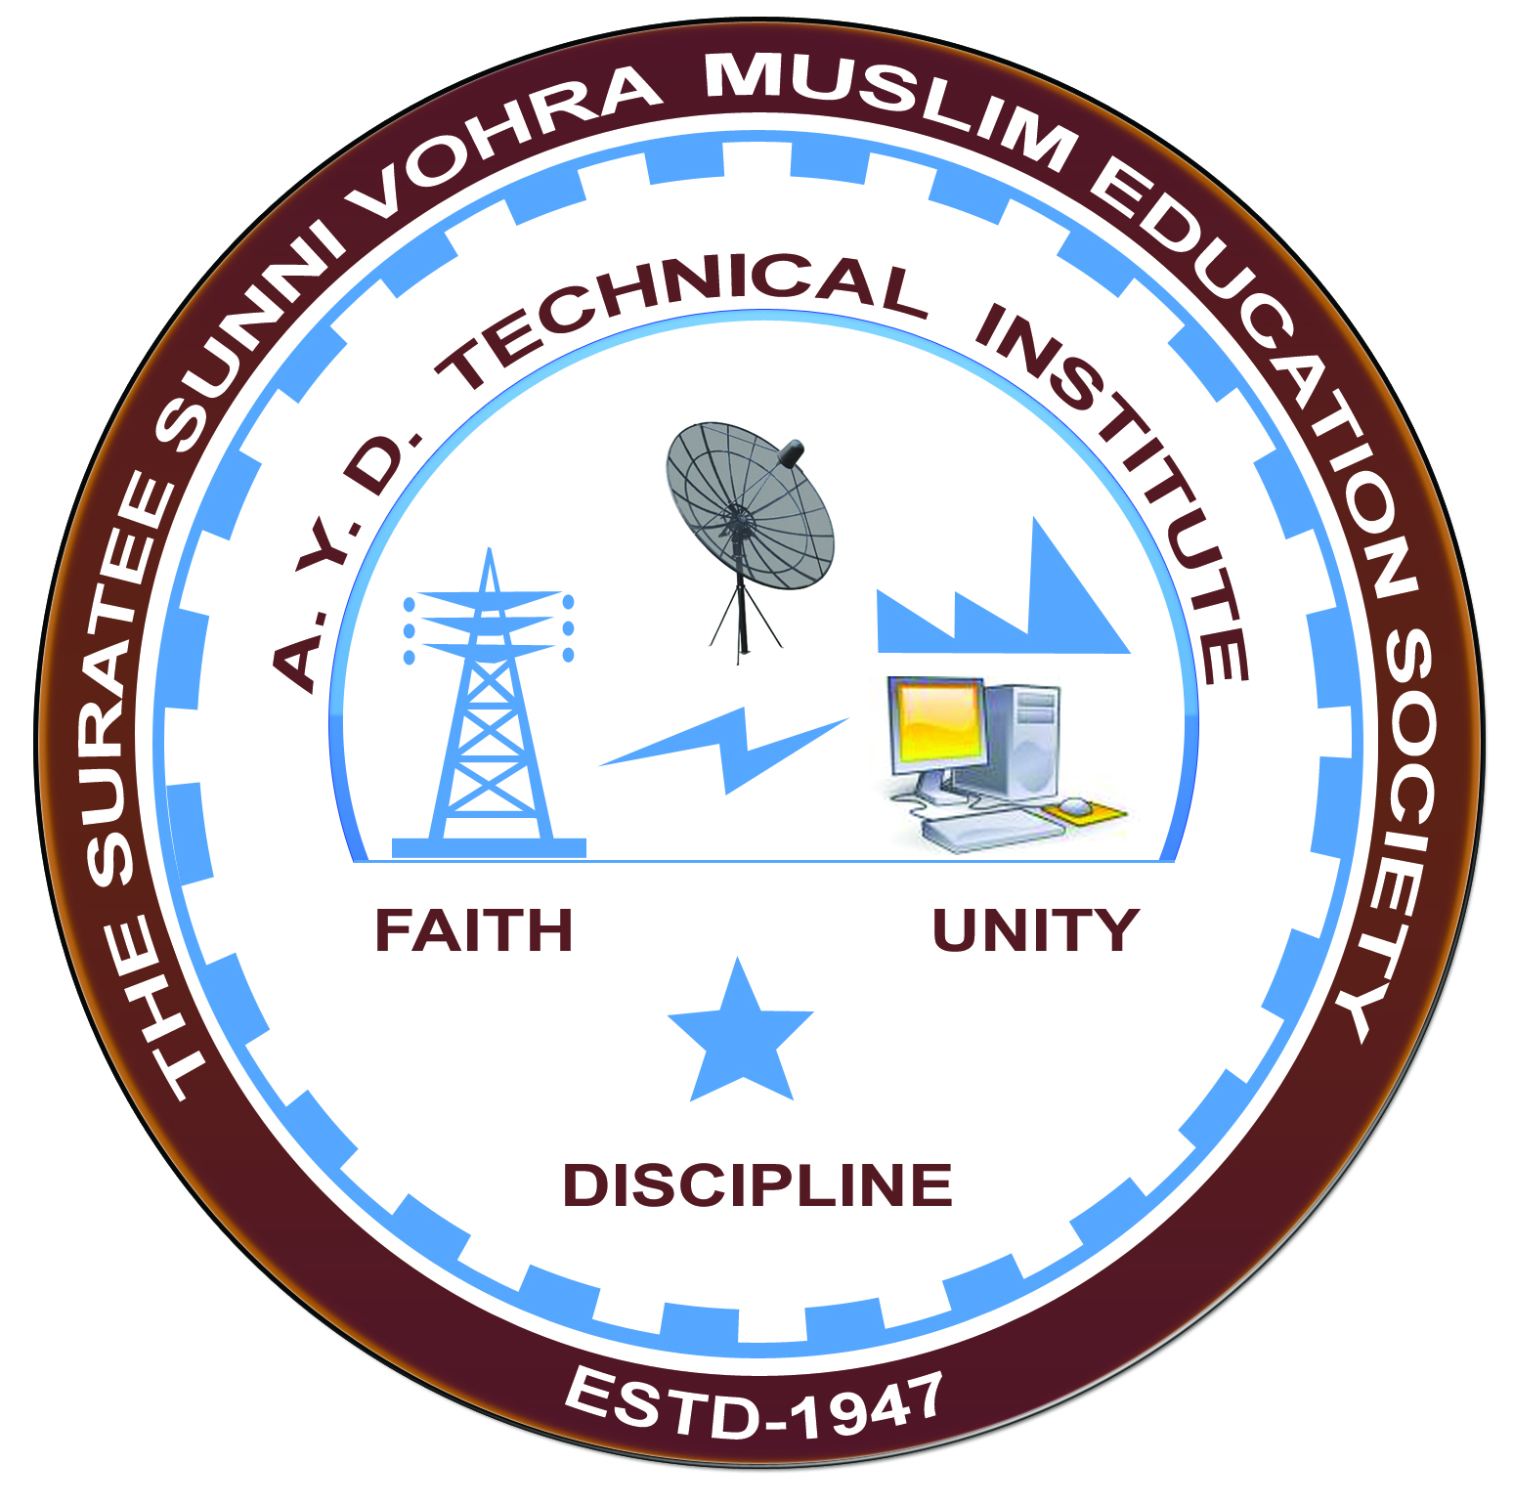

**Report on Expert Lecture**

**EMBEDDED SYSTEM DESIGN**

**DELIVERED BY MR.S.N.SAMPAT AND P.P. GAJJAR**

**&**

**Arranged by**

**Electrical Engineering Department,**

**A.Y.DADABHAI TECHNICAL INSTITUTE, KOSAMBA**

**EXPERT LECTURE**

**Date:-** 06-07-2019

**Department: -** Electrical Engineering

**Sem:-** 5th Semester

**Faculty:-** (1) Mr. M. Y. Patel

(2) Mr. M. A. Sheikh

**No of Students: -** 40

|  |  |  |
| --- | --- | --- |
| **Name Of Expert** | **Designation** | **Organization Of Expert** |
| 1.MR.S.N.SAMPAT | H.O.D. (EC DEPT.) | GIRLS POLYTECHNIC,SURAT |
| 2.P.P.GAJJAR | LECTURER (EC DEPT.) | GIRLS POLYTECHNIC,SURAT |

**Topic Of Expert Lecture:-** Embedded System Design

**Brief about Expert Lecture:-**

Our electrical engineering department of A. Y. Dadabhai Technical Institute, Kosamba Had organized expert lecture on embedded system design on the date of 06-07-2019

Mr.V.S.SAMPAT had given first basic introduction about embedded system, its organization structure & its block diagram. Also focusing how embedded system works & practical application of embedded system technology.

Finally Question answering between expert & students was made.

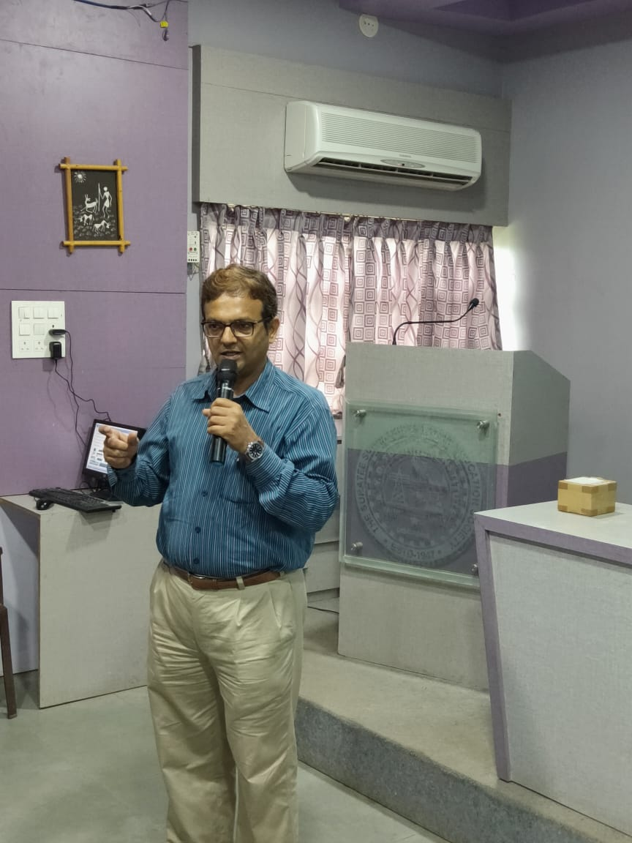

EXPERT DELIVERING LECTURE

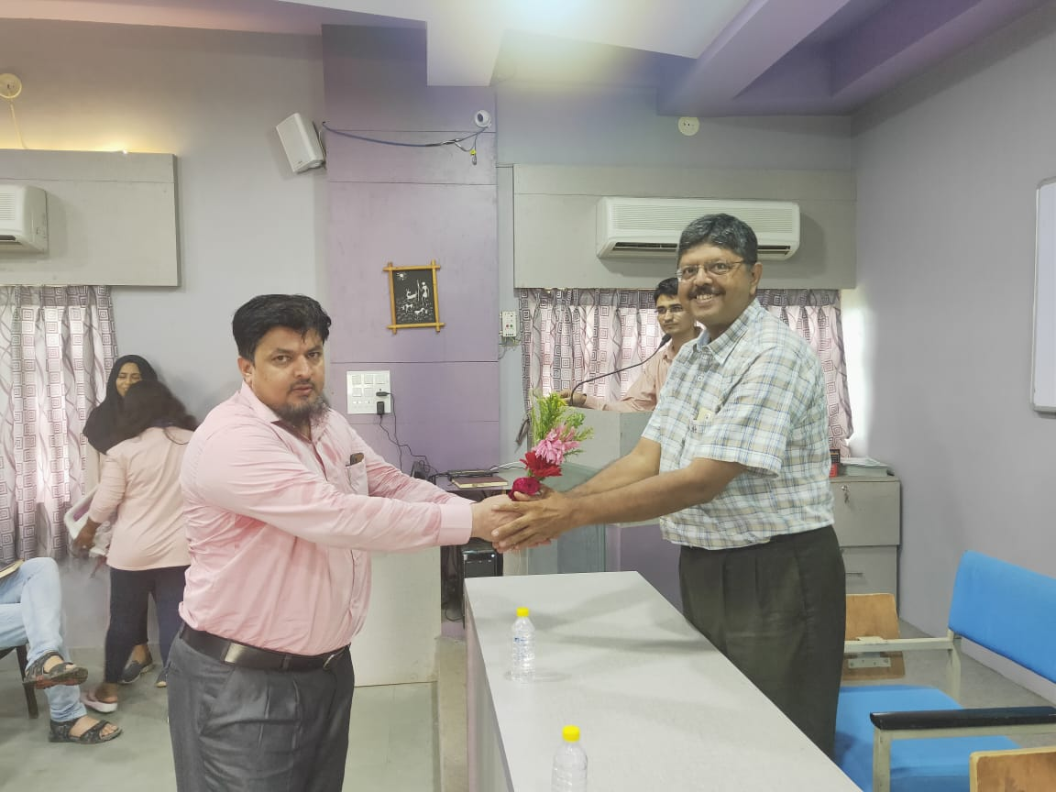

**WELCOME TO GUEST**

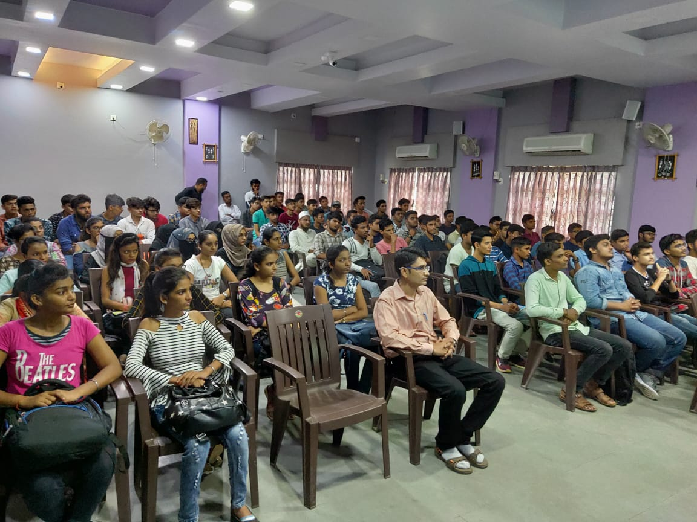

**STUDENTS PARTICIPATION**