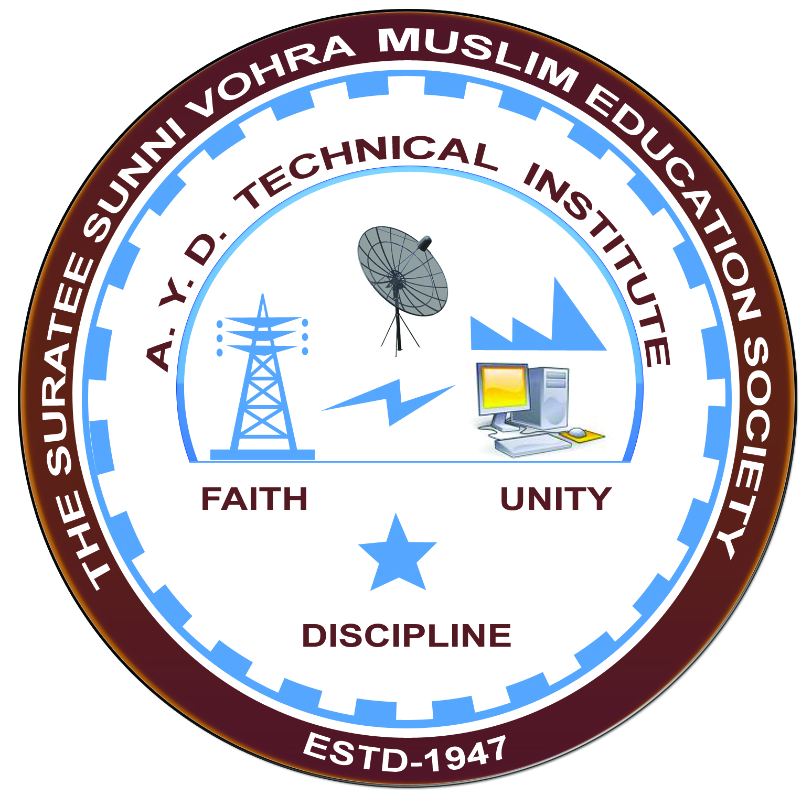

**UTRAAN GAS BASED POWER STATION (GSECL)**

**Arranged by**

**Electrical Engineering Department,**

**A.Y.DADABHAI TECHNICAL INSTITUTE, KOSAMBA**

**VISIT REPORT:**

**Date:-** 31/08/2019

**Department:S-** Electrical Engineering

**Semester:-** 3rd

**Subject:-** Electrical Power Generation

**No Of Students:-** 55

**Name Of Faculty:-**

1. Mr. M. A. Sheikh (Lecturer)
2. Miss. S. V. More (Lecturer)
3. Mr. R. J. Singh (Lecturer)

**Name Of Place/Company Visited:-** Utraan Gas Based Power Station (GSECL)

**About Company & Visit**

On the 31st of August 2019 our electrical Department has arranged an industrial visit for our 3rd sem students. Total 55 students & four faculty members had visited Utraan Gas Based Power Station.

**TECHNICAL DATA OF UTRAAN GAS BASED POWER STATION.**

* The Utran Gas Based Power Station is located on the bank of Tapi River near Surat. It is a Gas Based Power Station.
* There are two Projects – CCPP – 1 & CCPP – 2. In CCPP – 1 there are three gas turbine units of 30 MW each and one unit of 45 MW STG with a total installed capacity of 135 MW.
* In CCPP – 2 , there is one GT of 228 MW & one STG of 147 MW with a total installed capacity of 375 MW.
* The units of CCPP-1 are of BHEL make & the units of CCPP – 2 are of ALSTOM make.
* Commissioning dates of units of CCPP – 1 : GT#1, GT#2, GT#3 and STG are 17.12.1992, 28.12.1992, 07.05.1993 and 17.07.1993 respectively & CCPP – 2 : GT – 10.07.2009 & STG – 10.10.2009. The CCPP – 2 is taken under commercial operation since 08.11.2009.

**PHOTO GALLERY:**

