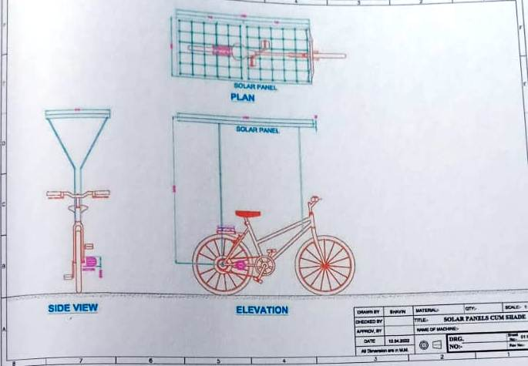

1. **Name of Project:** ***“Solar Bicycle”***
2. **Name of Students:**
3. Padhiyar Yuvraj J.,Parmar Bhavin A. ,Parmar Dhrumil S. ,Parmar Manmeet D.
4. **Name of Guide:** **Mr. K.H. Patel**
5. **Technical Theory:** Utilization of renewable energy, i.e. solar energy for Bicycle.
6. **Utility:**

This kind of project using solar energy in bicycle which save human efforts and also used as alternate of any two wheeler running on petrol.

1. **Cost:** Rs. 15,390/-
2. **Merits:**

* It using renewable energy sources.
* It saves the conventional energy source.
* It saves human efforts.
* It contains low maintenance cost.
* It is pollution free & causes no greenhouse gases.
* It is very much viable for city ride.
* It is very much cost effective comparing to market cost of such bicycle is Rs. 30,000/- (Approx.)