|  |  |  |
| --- | --- | --- |
| D:\broucher, banner, logo & profile\Logo\AYDTI, Kosamba - Copy.jpg | **A Y DADABHAI TECHNICAL INSTITUTE, KOSAMBA** | D:\broucher, banner, logo & profile\Logo\logo_t&p - Copy.jpg |

**Entrepreneurship Development Cell**

**ENGLISH OLYMPIAD**

**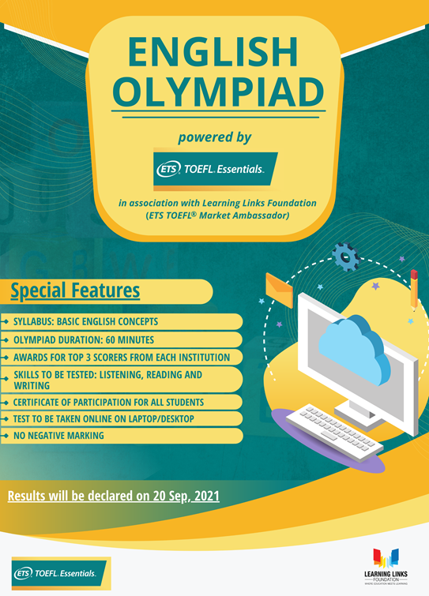**

***Date: - 28th August, 2021***

***Saturday***

***MODE- ONLINE***

Our institute Successfully organized English Olympiad in collaboration with learning skill Foundation CETS authorized Resource center

Learning Skill Foundation is the official country ambassador & the TOEFL/ IBT™ Resource center in India for Educational testing service (ETC –USA), The longest non-profit organization in the world responsible for conducting of TOEFL@ and GPE@ globally our institute takes initiative for this test &Register Students total 98Students of Different department had given this test out of this below three Student Secured Rank at institute level

|  |  |  |  |
| --- | --- | --- | --- |
| **Sr. no** | **Name of Students** | **Marks obtained** | **Department** |
| 1  2  3 | Fatemabibi Shaikh  Tauhid Mashaahadi  Mulla Jamil Ahmed | 50  45  43 | Computer Engineering  Computer Engineering  Electrical Engineering |

* Learning skill foundation provides
* 1class trophy for Institution
* A3 size framed certificate for Institution
* 3Momtoes for 1st,2nd &3rd position holders
* TOEFL Essential bags
* TOEFL Essential information collaterals
* Bookmarks