|  |
| --- |
| **A. Y. DADABHAI TECHNICAL INSTITUTE,**  **KOSAMBA (R.S.)** |

**28th January, 2017**

***A REPORT***

***On***

***“Teachers’ Training Programme”***

**under**

**ISTE-STAFF CHAPTER**

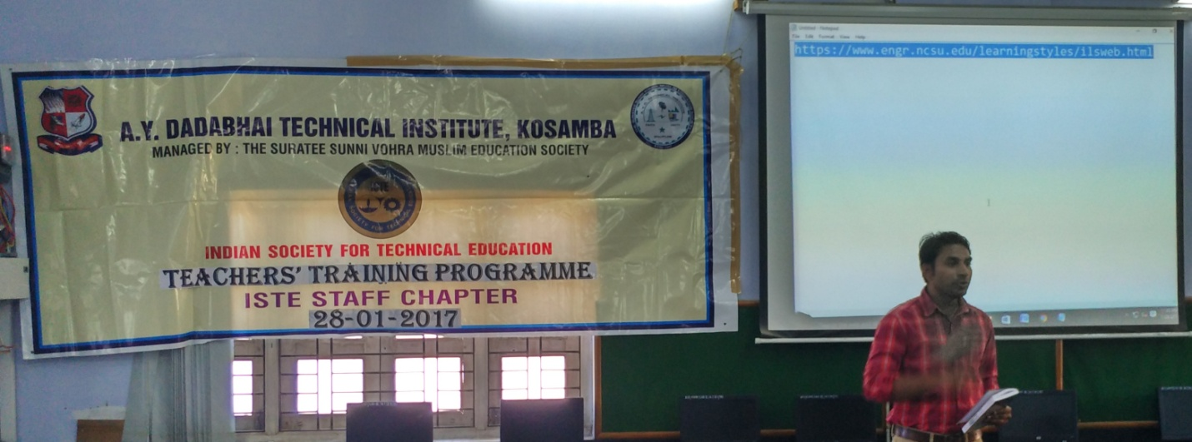

To improve teaching skills as well as resolve some problems regarding the learning methods, A. Y. Dadabhai Technical Institute, Kosamba (R. S.) organized **“Teachers’ Training Programme”** under the ISTE-STAFF CHAPTER on Saturday 28th January, 2017. Guest lecture was attended by more than 50 staff which was started sharp at 11:30 am in the morning.

The speaker is **Dr. I. B. Dave** had started session with some basic questions to staff members that what kind of problems they were faced during their teaching. Many questions raised by the audience which was listed to discussed later during session. He gave idea of ***Index of Learning Style*** and told about ***BLOOM’S TAXONOMY ACTION VERB***.

Introduction

|  |  |
| --- | --- |
| E:\1. SABIR\AYD\CULTURAL REPORT\20 iste staff chapter guest lect staff training program\New folder\IMG_20170128_114337_HDR.jpg | E:\1. SABIR\AYD\CULTURAL REPORT\20 iste staff chapter guest lect staff training program\New folder\IMG_20170128_114802_HDR.jpg |
|  |  |
| E:\1. SABIR\AYD\CULTURAL REPORT\20 iste staff chapter guest lect staff training program\New folder\IMG_20170128_114541_HDR.jpg | E:\1. SABIR\AYD\CULTURAL REPORT\20 iste staff chapter guest lect staff training program\New folder\IMG_20170128_114404_HDR.jpg |

He told about **six** layers of teaching or to focus during teaching. This layer is divided the syllabus as well as many thing related to study.

After the discussion, he started ***online Question-Answer session*** which contains 45 questions to be completed in 20 min. by staff members. He continuously instructs the staff members to give the answer of all questions **by heart and not by brain.**

After the completation of Exam session, he started to explain about ***“NET Generation”*** in which students are placed in ***digital native*** and staffs are placed in ***digital immigrant.***

online Question-Answer session

|  |  |
| --- | --- |
| E:\1. SABIR\AYD\CULTURAL REPORT\20 iste staff chapter guest lect staff training program\New folder\IMG_20170128_120409_HDR.jpg | E:\1. SABIR\AYD\CULTURAL REPORT\20 iste staff chapter guest lect staff training program\New folder\IMG_20170128_120348_HDR.jpg |
| E:\1. SABIR\AYD\CULTURAL REPORT\20 iste staff chapter guest lect staff training program\New folder\IMG_20170128_120600_HDR.jpg | E:\1. SABIR\AYD\CULTURAL REPORT\20 iste staff chapter guest lect staff training program\New folder\IMG_20170128_120500_HDR.jpg |

He concluded that main reason of the student problem is “what they want, we can’t deliver”. He said that students were very poor in one-to-one relation though they are multitasking as well as very good in social media. He told about some online courses to enhance teachers effectiveness. He gave some idea to identify ***different learning style*** of students which help us to teach them better.

RESULT DISCUSSION session

|  |  |
| --- | --- |
| E:\1. SABIR\AYD\CULTURAL REPORT\20 iste staff chapter guest lect staff training program\New folder\IMG_20170128_120737_HDR.jpg | E:\1. SABIR\AYD\CULTURAL REPORT\20 iste staff chapter guest lect staff training program\New folder\IMG_20170128_121433_HDR.jpg |

Latter on they discussed on the RESULT of the exam taken earlier in the session. He told that basis on this result, you as well as students can be classified in to different categories listed below and discussed their characteristics:

1. Sensetive Learner – Intutive Learner
2. Visual Learner – Verbal Learner
3. Active Learner – Reflective Learner
4. Sequential Learner – Global Learner

He concluded the session with golden advice that to deliver something new to students, what they want.