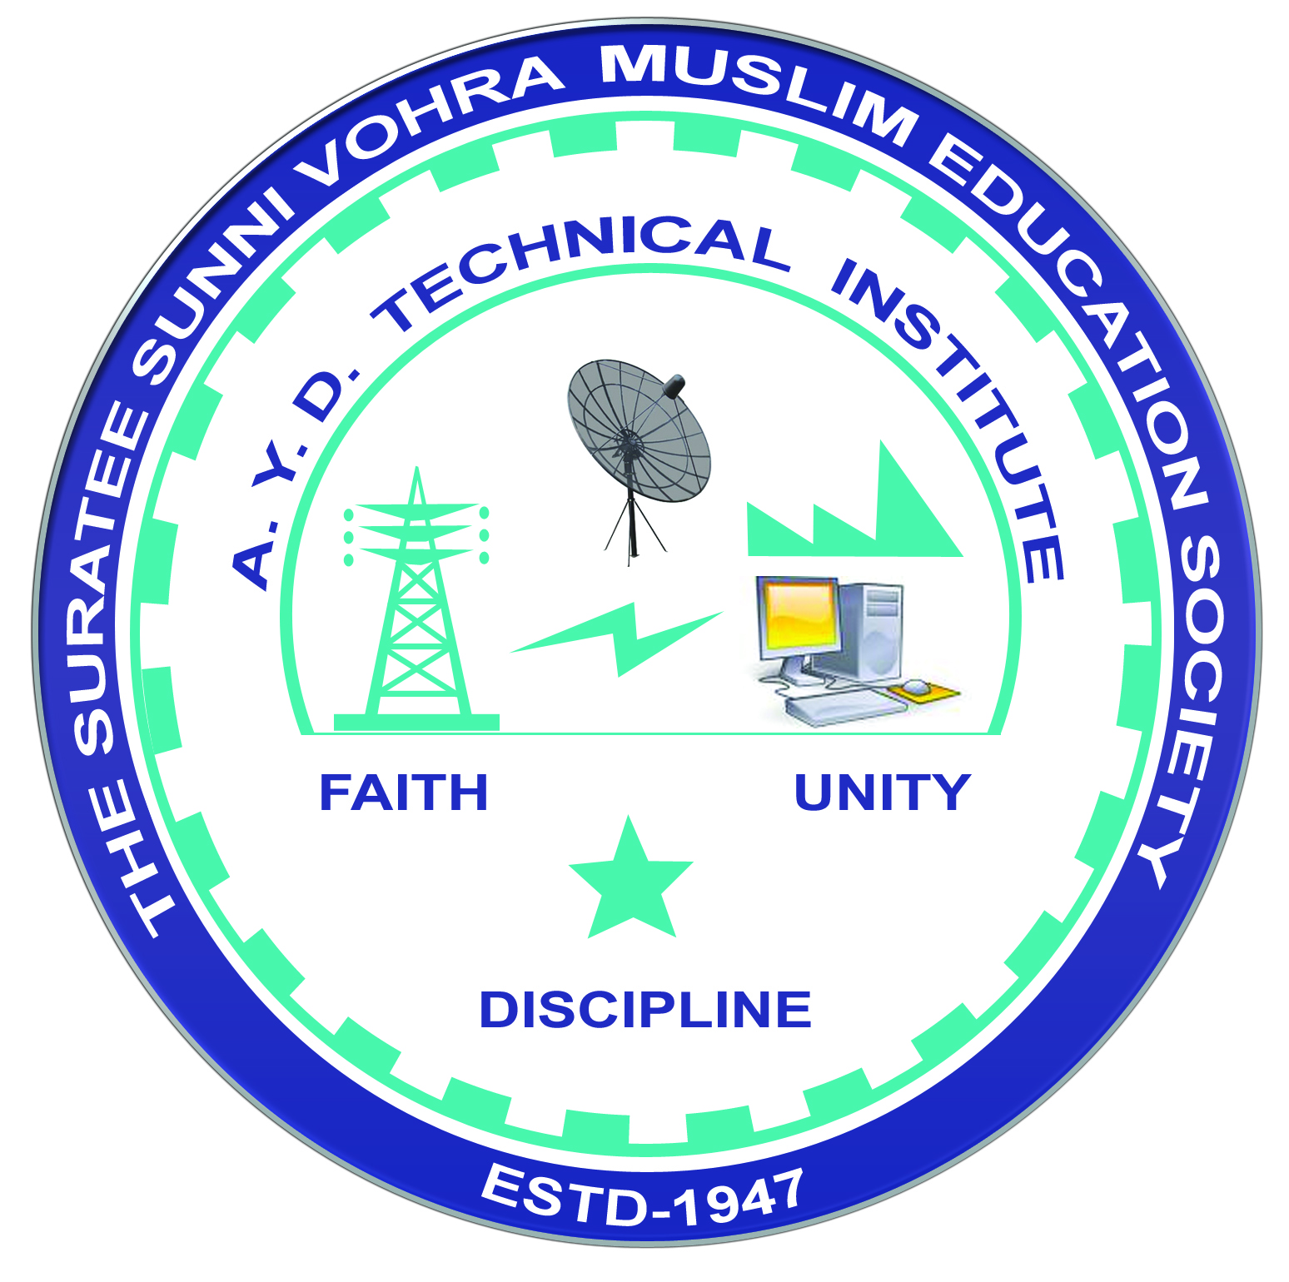 | A.Y. DADABHAI TECHNICAL INSTITUTE, KOSAMBA | 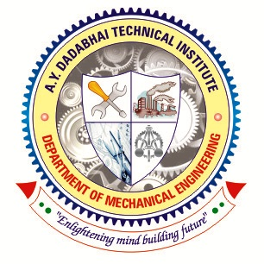

DEPARTMENT OF MECHANICAL ENGINEERING

One Day Educational Visit of Industry

Name of Industry: Shree Khedut Sahakari Khand Udyog Mandli Ltd. – Pandvai.
Address: P.B. No. – 3, Pandvai, Ta-Hansot, Di-Bharuch.
Date of Visit: 01-02-2020
Subject (Course) Related to Industry:
Thermal Engineering - I (3341902)
Product of Industry: Sugar, Molasses.
Name of departments visited in Industry: Production, Power Plant, Water Treatment Plant, Maintenance Dept, and Storage.
Contact person of Industry: Commercial Manager – Mukeshbhai Patel.
Faculties from Institute:
- Mr. S.A. Kapadia
- Mr. Y.A. Sakpal
- Mr. C.N. Patel
- Mr. S.H. Patel
- Mr. D.R. Patel
- Mr. R.A. Vansadiya

