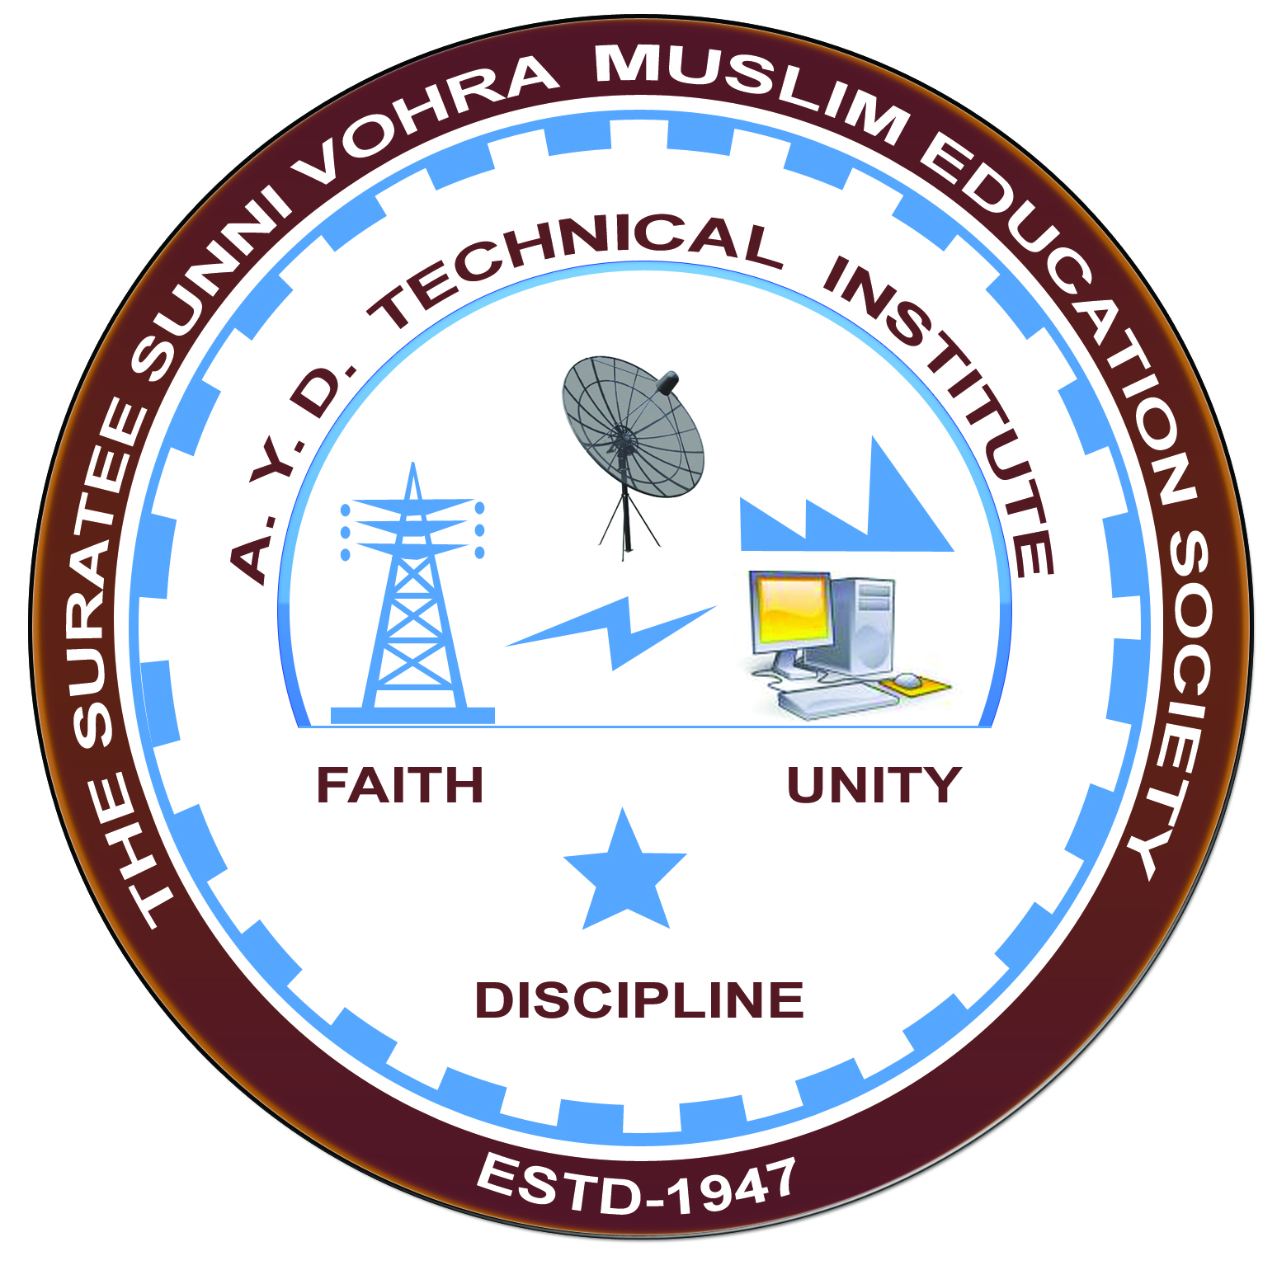

**WANAKBORI THERMAL POWER STATION,ANAND**

**Arranged by**

**Electrical Engineering Department,**

**A. Y. DADABHAI TECHNICAL INSTITUTE, KOSAMBA**

**VISIT REPORT**

**Date:-** 16/09/2022

**Department: -** Electrical Engineering

**Semester: -** 5TH SEM

**Subject:-** introduction to power generation using coal.

**No Of Students: - 55**

**Name Of Faculty:-**

1. SNEHA R MANIK (LECTURER)
2. MR. M.Y.PATEL (LECTURER)
3. MISS M.R.VANSIYA (LECTURER)
4. Mr. H. N. DESAI (Lab Technician)
5. MR P.J.PATEL (lab Assistant)
6. Mr J.C.PARMAR (lab Assistant)

**Name Of Place/Company Visited:-** WANAKBORI THERMAL POWER STATION

**About Visit**

On the 16th SEPTEMBER 2022 our electrical Department has arranged an industrial visit for our 4th SEM students. Total 55 students & 6 faculty members had visited the WANAKBORI THERMAL POWER PLANT.

On receiving the permission letter from WANAKBORI THERMAL POWER STATION,GSECL 55 students with 5 faculties went on industrial visit to amul dairy. We all assembled at the college at 5 a.m. We reached the plant at 11.00 a.m. An engineer in charge received us at the entrance and gives the brief introduction about the plant.

W.T.P.S is the biggest thermal power plant of GSECL, GUJARAT.it is coal fired power station.it is located on the bank of mahi river in kheda district. There are 7 turbo generator sets aeach of 210 MW out of which first 3units are equipped with Russian turbines and 4 units are equipped with German turbines. All above units are made by BHEL.

following sections are visited

1. Training center
2. Coal and ash handling plant
3. Boiler section
4. Turbine/Generator floor
5. Electrical control room (Unit No.3)
6. Cooling tower
7. Switch yard (220kV & 400 kV)

At the training center, Training Officer explained the working cycle of thermal power station. We visited various small scale models of equipment used in the power plant. We collected very important practical data like temperature, pressure, quantity of coal, etc. used for the power generation. We visited the coal and ash handling plant where Training Officer guided us. The 210 MW unit consumes 125 ton coal per hour to generate the electricity. So, bulk amount of coal is transported through railway and with the help of Wagon. Tripler coal is transferred to the coal storage area. In 2012, Gujarat State Electricity Corporation proposed an additional unit 8 of 800 MW to the power station, originally projected to be commissioned in 2015 to 2016.

The project received environmental clearance in December 2013. Construction began in 2014. It is planned for operation in 2018.The control room of power plant is the brain of the entire plant. We visited control room. It is equipped with DCS facility provide by ABB Ltd. All the important data were displayed in real time mode like MW, MVAr, frequency, power factor phase current, etc. on the display screen. There are 7 natural draught cooling towers (NDCT) used for cooling of circulating water of condenser. Switch yard consists of two sections, 220 kV and 400 kV. The voltage of unit no. 1, 2 and 3 is stepped up from 15.75 kV to 220 kV and the power is transmitted at 220 kV level. There are 7 outgoing transmission lines at 220 kV voltage level. The voltage of unit no. 4, 5, 6 and 7 is stepped up from 15.75 kV to 400 kV and the power is transmitted at 400 kV level. There are 4 outgoing transmission lines at 400 kV voltage level. The visit was very fruitful as we observed each of energy conversion stages used in power plant starting from fuel section to switch yard. We collected very important information like practical data which are not available in books and other literature. Many of our doubts are cleared by the discussion with experts of the plant. We left WTPS at 5.00 PM

**Visit Photograph**

