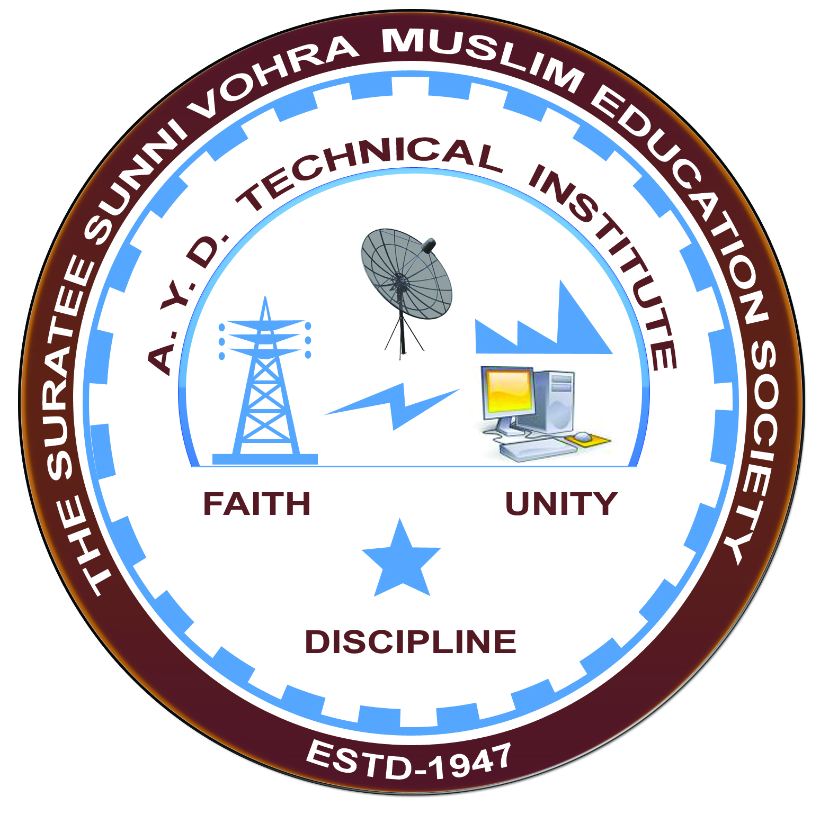

**ACTIVE ELECTRICALS, JOLVA**

**Arranged by**

**Electrical Engineering Department,**

**A.Y.DADABHAI TECHNICAL INSTITUTE, KOSAMBA**

**VISIT REPORT**

**Date:-**10/01/2023

**Department: -** Electrical Engineering

**Semester: -**3RD SEM

**Subject:-**Understanding the construction and design of transformers

**No Of Students: -**45

**Name Of Faculty:-**

1. SNEHA R MANIK (LECTURER)
2. MR. R.J.SINGH (LECTURER)
3. Mr. H. N. DESAI (Lab Technician)

**Name Of Place/Company Visited:-**ACTIVE ELECTRICALS.

**About Visit**

On the 10thJANUARY 2023 our electrical Department has arranged an industrial visit for our3RD SEM students. Total 45 students& 3 faculty members had visited the ACTIVE ELECTRICALS ,JOLVA.

On receiving the permission from ACTIVE ELECTRICALS. We all assembled at the college at 8a.m. We reached the plant at 10.00 a.m. An engineer in charge received us at the entrance and gives the brief introduction about the plant.

Active electricals offers wide range of quality all type of TRANSFORMERS, VARIAC, SERVO STABILIZER, CVT, LINE REACTOR and RECTIFIER that conforms to international quality standards.Ourfully-integrated factory is equipped state of the art machinery forcore Laminations,coil-winding,Ovening, oil filtration, tank fabrication, testing & packing of transformers.

**Visit Photograph**

